Project E-commerce

**1)Month of Sales**

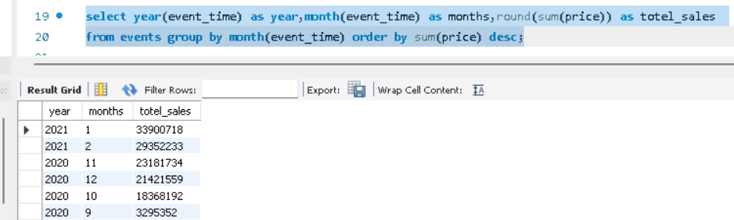

There is highest sale in **January 2021** month which is 33900718 and lowest sale in **September 2020** month which is 3295352.

**3. Top brands by Sale:**

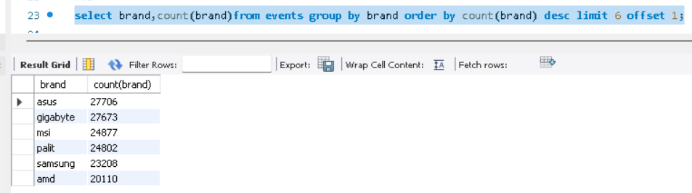These brands are top 6 brands in a list.

**4)Demand for Items:**

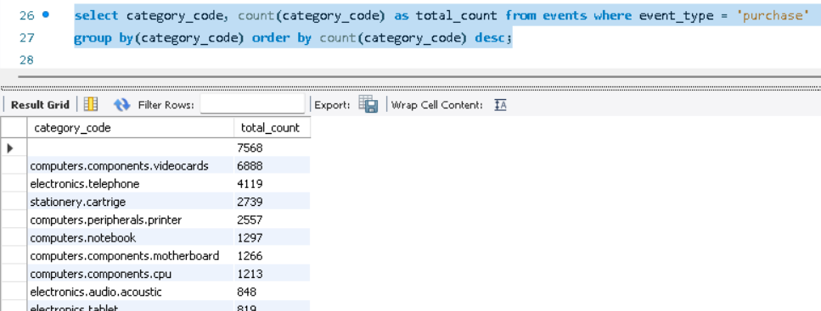

These are most demanded items having max purchase count is 6888.

**5)Frequency of Purchase**

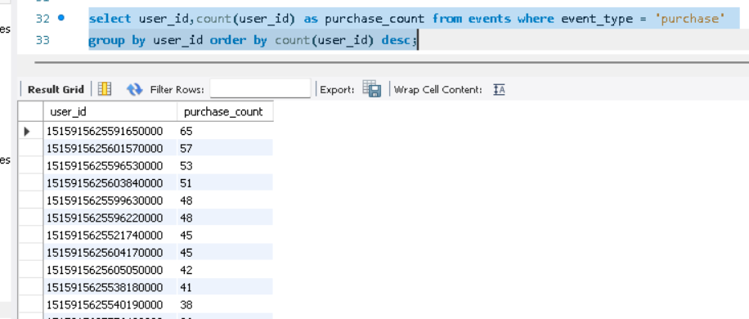

The user id **151591562559165000** is topmost from customers having max purchase count which is **65**

**Chart Shows Top 5 User**

**6)Actual Time purchased**

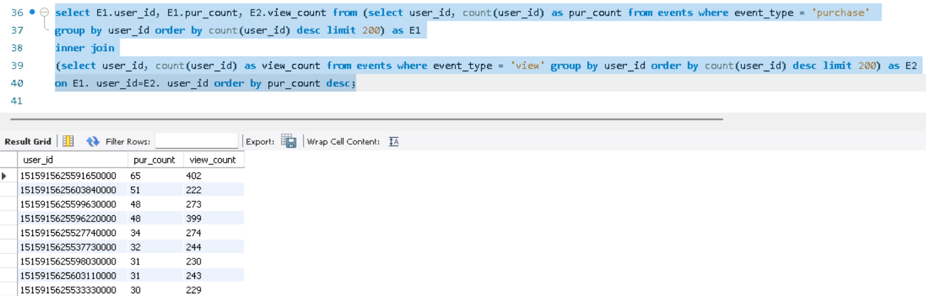

Total view count is more than purchase count from that we can conclude that people are viewing more items but not actually purchasing them.